**AI-Powered Pickleball Feedback System: Two Approaches for Player Detection and Posture Evaluation**

<https://github.com/ashitakolla/ai-video-feedback>

**Overview**

The goal of the AI-powered Pickleball Feedback system is to provide feedback on player posture and field positioning during a Pickleball stroke or serve. This system utilizes computer vision models, such as YOLO (You Only Look Once), and a custom feedback system to analyze videos uploaded by users, providing detailed insights into player posture, movement, and positioning. Switched from MediaPipe to YOLO because MediaPipe struggles with **multi-player detection**.

In the process of development, two distinct applications were created for testing and demonstration purposes:

1. **YOLO-Based Player Detection (Test Version)**
2. **Streamlit-Based AI Feedback System (Final Version)**

**1. YOLO-Based Player Detection (Test Version)**

The initial version of the system was built using YOLO for detecting players and analyzing their positions on the field. The key functionality of this test version is:

* **Player Detection:** YOLO successfully detects multiple players within the video frame. The model is trained to identify players and track their movements during the video.
* **Field Positioning:** After detecting the players, the system tracks and reports the positioning of each player on the field, including their posture and general movements.
* **Basic Pass/Fail Evaluation:** The system evaluates the player's positioning, assigning a "pass" or "fail" status based on the detected posture and field position.

The main advantage of the YOLO-based version lies in its ability to detect both players simultaneously, providing a clear view of both their positions in real-time. However, this system does not offer any feedback on why a player's position is considered faulty or rejected.

**2. Streamlit-Based AI Feedback System (Final Version)**

The second version of the system, built with Streamlit, incorporates a more comprehensive evaluation system along with a custom feedback mechanism. This version builds on the foundation of YOLO detection but introduces a more interactive user experience and more advanced functionality:

* **Multi-Player Detection:** Streamlit allows for a streamlined interface to upload and display video. However, there were challenges with detecting multiple players, which was causing the system to detect only one player during the analysis.
* **Posture Feedback:** The core feature of this version is its ability to give feedback based on the posture detected in the video. For instance, if a player’s posture is deemed incorrect or unsuitable, the system provides detailed feedback on why it was rejected. This feedback might include reasons like improper foot placement, body alignment, or failure to execute the correct stroke form.
* **Field Position Evaluation:** Similar to the YOLO version, this system evaluates the player’s position on the field, but also provides a deeper analysis of whether their position is optimal for executing a good stroke or serve.

The key advantage of the Streamlit version is its feedback mechanism, which goes beyond a simple pass/fail system. It provides users with valuable insights into how to improve their posture and technique. However, it currently struggles with detecting both players simultaneously, an issue that needs to be resolved in future iterations.

**Key Differences Between the Two Versions**

1. **Player Detection:**
   * **YOLO Version:** Detects both players accurately in the video.
   * **Streamlit Version:** Can detect only one player due to limitations in the current implementation.
2. **Feedback:**
   * **YOLO Version:** Only provides position tracking with a pass/fail evaluation.
   * **Streamlit Version:** Provides detailed feedback for rejected positions, explaining why the position is considered incorrect, along with suggestions for improvement.
3. **User Interface:**
   * **YOLO Version:** No user interface, runs directly in a script.
   * **Streamlit Version:** Provides an interactive user interface with video upload capabilities, making it more accessible to end users.
4. **YOLO-Based Player Detection (Test Version)**

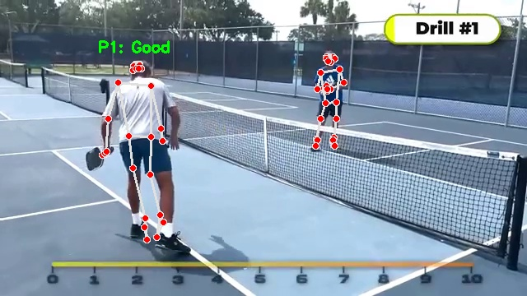

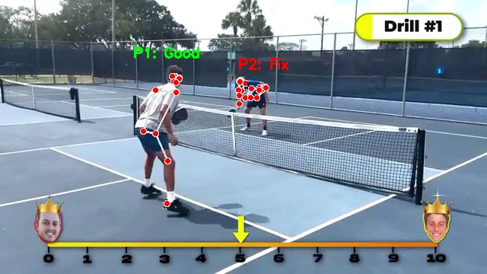

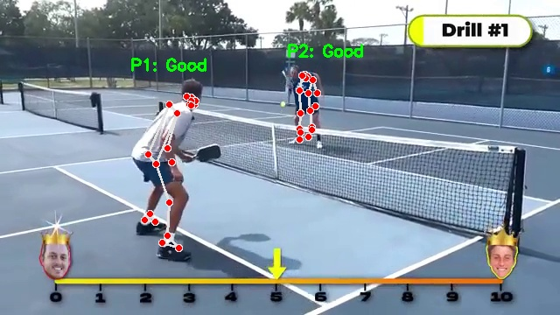

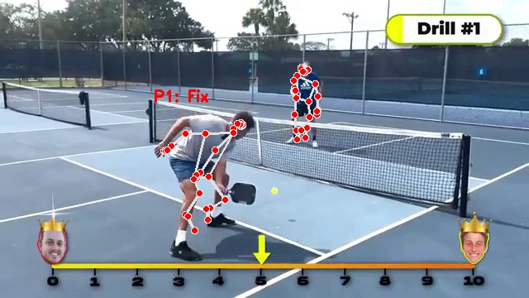

1. **Streamlit-Based AI Feedback System (Final Version)**



**Conclusion**

Both versions of the system serve different purposes in the development process. The YOLO-based version is useful for player detection and basic positioning, while the Streamlit-based version offers more in-depth feedback on player posture and technique. The ultimate goal is to merge the capabilities of both systems: retaining the multi-player detection from YOLO while incorporating the detailed feedback system from Streamlit to provide users with comprehensive AI-driven insights on their Pickleball technique.